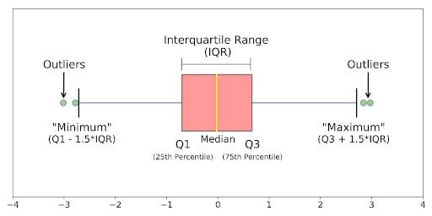

We use this method when our data is skewed.
Q1 is 25% of the data (It means 25% of data are less this point)
Q3 is 75% of the data. (It means 75% of data are less this point)
Median in 50% of the data. (It means 50% of data are less this point)

IQR is difference between Q1-Q3

We calculate minimum and maximum.

Minimum = Q1-1.5 * IQR
Maximum= Q3+1.5 * IQR

